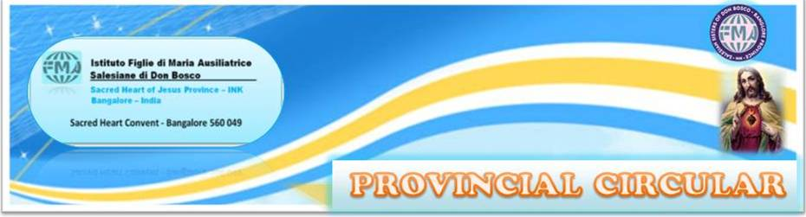
XXX/ 07 02 December 2022

My dearest Sisters,
Prayerful and affectionate Greetings from the Provincial House Bangalore!

We are already in the season of Advent, the joyful season of waiting for the coming of our Redeemer. The Lord is coming, always coming… through joys and sorrows, successes and failures…and even through least expected events.
“Have you heard His silent steps? He comes, comes, ever comes.
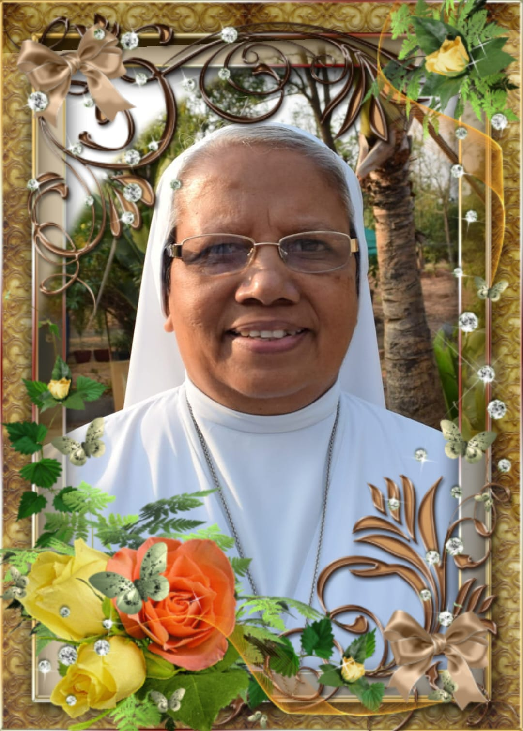
Every moment and every age, every day and every night He comes, ever comes”- so sang our great Indian mystic poet, Rabindranath Tagore.
On the first day of the liturgical year, the first Sunday of Advent, He came….to our dear Sr. Crescentia D’Almeida… she heard those silent steps and the gentle calling of the Master of life. In the blink of an eye, He plucked that ripe fruit from the Salesian garden...without leaving her time even to say a goodbye to anyone. Her room in heaven was already ready…As a wise virgin, she had sent ahead enough materials to build and furnish her room. If He were to ask our permission to take her from us, to give her the much merited reward, He would not have got it. So He took her away, without getting our consent! She was too good to stay in this world for more years. Hers was a life lived fully and joyfully in the service of the Lord and his people. But for all of us, it was a real shock …the suddenness of the departure and the sense of irreparable loss plunged us into a sea of sorrow. Yet, we have to say, “Thy will be done O Lord”.

This year the Novena to Mary Immaculate is very special for us. On the first day, Mother General called it ‘a very long day’. We all gathered around the mortal remains of our dear departed to lay her to rest so that she may rise to life in Christ. She loved Our Blessed Mother tenderly. She will introduce her to the joys of eternal life. The loving brothers and sisters of Sr. Crescentia with their families, especially our dear Sr. Ritsel Ann D’Almeida accepted in faith the shocking reality of her least expected departure, from the hand of the Father and accompanied her to the end.
Many people, priests and religious made their way to say “Good bye” to her. The Members of the Salesian Family and Educating Communities stood by us as we bade farewell to our dear Sister. Fr. Jose Koyickal the Salesian Provincial of Bangalore and the Salesians of Kristu Jyoti College, Visvadeep, and Don Bosco Renewal Centre expressed great solidarity in those difficult moments. Fr. Thomas Santiago the Salesian Provincial of Hyderabad and many Salesians reached us with their messages of condolences and prayerful support. The FMA India and our communities across the Globe, including Mother Yvonne Reungoat, shocked at the news, tried to reach us through their messages. Sr. Nirmala Lazar Provincial of Chennai and PCI President, Sr. Margaret Amalanathan Provincial of Trichy with their Sisters, and the Members of the FMA History Commission from the seven FMA provinces of India shared our moments of sorrow and pain.
Mother General wrote to tell us dear sisters, expressing her affection and closeness and that of the General Council. “Death is truly a mystery to us, especially when it comes unexpectedly. Sr. Crescentia was ready but we are the ones who are shocked and impressed. I imagine the sisters of the community of Nirmal Jyothi, of the Province. It doesn’t seem real to us that we are far away; I imagine what you feel and what everyone feels. Not only we, but also the sisters of the Generalate, are close to you in prayer and affection, in memory of Sr. Crescentia but also thinking of all of you. I entrust all of you to Mary Immaculate in this particular novena. She has already welcomed and accompanied our Sister to receive the reward of a faithful servant. May She fill you, the Sisters of the Province and her family with consolation and comfort”.
With Heartfelt condolences and in deep sympathy, feel me close to you.”
Let us continue to offer prayers and suffrages for our beloved Sister Crescentia and for her bereaved family members.

IMMACULATE CONCEPTION
We honour Mary as a woman who is unique, in the strict meaning of that word, not as we sometimes use it, meaning exceptional, outstanding, rare, and unusual. Mary can actually be described by any one of those words, but more accurately, she is unique: conceived without flaw, without blemish, without imperfection, without sin unlike any other person. Her Immaculate Conception is indeed unique, but in her everyday life, she offers us a less rarefied companion and model of living.
The most Blessed Virgin Mary was, from the first moment of her conception, by a singular grace and privilege of almighty God and by virtue of the merits of Jesus Christ, Saviour of the human race, preserved immune from all stain of original sin. By the grace of God Mary remained free of every personal sin her whole life long. “Let it be done to me according to your word. . .” Mary is “the most excellent fruit of redemption” (SC 103): from the first instant of her conception, she was totally preserved from the stain of original sin and she remained pure from all personal sin throughout her life.
In our desire to be more like Mary of Nazareth and more intimately related to our loving God, on this feast-day let us renew our commitment: to a vowed life of faithfulness to God, faithfulness to one another in community, faithfulness to God’s people, especially the poor.
In celebrating the feast of Mary Immaculate, which underscores her uniqueness, we are reminded that each of us is also unique in our own way, also marked by a bit of mystery and miracle.
Mary always leads us to Christ. She is the one who shows us how to live lives of holiness. Let us ask her help and support in all that we do.
Let us celebrate this feast contemplating Mary’s total dedication to God and neighbor. If celebrated with fervor and devotion, Mother Mary will fill our hearts and houses and those of our recipients with her choicest blessings.

WHERE GOD IS BORN, HOPE IS BORN
Let us prepare our hearts to receive the
Blessings of Christmas day! A day of mercy, in which God our Father has revealed his great tenderness to the entire world. A day of light, which dispels the darkness of fear and anxiety. On this day, Jesus, the Savior, is born of the Virgin Mary. We see the sign which God has given us: “a baby wrapped in swaddling clothes and lying in a manger.”
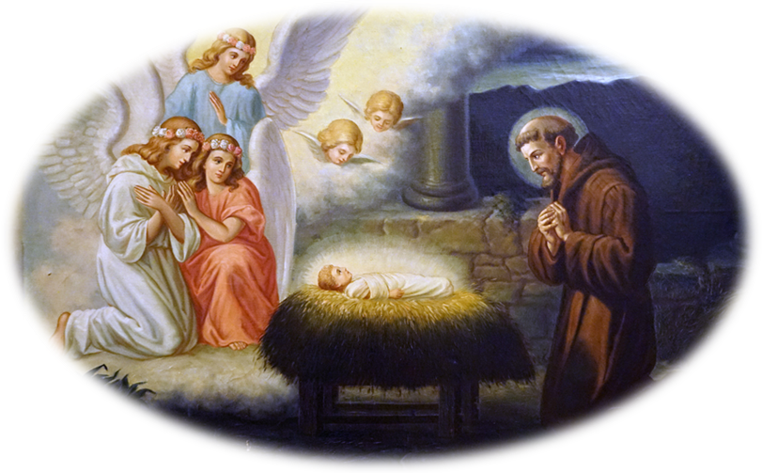
Where God is born, peace is born; and where peace is born, there is no longer room for hatred and for war. Where God is born, hope is born; and where hope is born, persons regain their dignity. Yet even today, great numbers of men and women are deprived of their human dignity and, like the child Jesus, suffer cold, poverty and rejection. May our closeness today be felt by those who are most vulnerable! Today, then, let us come together to rejoice in the day of our salvation. As we contemplate the Crib, let us gaze on the open arms of Jesus—the merciful embrace of God. We hear the voice of the Child who whispers to us: “Peace.” Let us allow this season, fill our heart and let go of the things we dislike.
Let us widen the circle of our prayer to include the whole world, especially our Holy Father Pope Francis, our Superiors, all our Animators, Sisters, parents and dear ones, benefactors, and all the members of our Educating Communities. Let us not forget the war-stricken Ukraine and its suffering population.


03 - ST. FRANCIS XAVIER
05 - BL. PHILIP RINALDI
08 - IMMACULATE CONCEPTION
10 - HUMAN RIGHTS DAY
12 - OUR LADY OF GUADALUPE
25 - CHRISTMAS
26 - ST. STEPHEN
27 - ST. JOHN THE APOSTLE & EVAGELIST
28 - HOLY INNOCENTS
30 - HOLY FAMILY


NATIONAL BOSCOREE
The 14th National BOSCOREE will be held from 29th December 2022 to 2nd January 2023 at Assam Don Bosco University, Tapesia Gardens, Guwahati. Scouts and Guides from our Schools in Secunderabad and Bangalore will be participating. I wish all the participants: staff, students and sisters a very fruitful and enriching experience. May it help everyone for their integral growth as God-fearing and responsible citizens of India in the spirit of Don Bosco and St. Mary Mazzarello!

EXPRESSIONS OF GRATITUDE
Sr. Agnes Fernandez expresses her thanks to each one of you dear Sisters and children who prayed earnestly for her recovery and good health. Now that she is able to be on her feet and look forward to be in her mission in the near future, she is grateful to God and our Blessed Mother and all those who were by her side with their prayerful support.

SINCERE ASSURANCE OF PRAYERS
- To Sr. Cecily Thomas at demise of her niece and cousin of Sr. Annie Kumplankal, Mrs. Kunjamma Joseph (81) on 09 November 2022.
- To Sr. Crocetta Thomas at the passing away of her cousin brother Fr. John Maria Joseph (51) on 10 November 2022.
- To Sr. Miriam Vettukallel at the demise of her cousin Mr. John Vettukallel (56) on 18 November 2022.
- Fr. Agilan Sarprasadam, Provincial and the Confreres of INT on the demise of Fr. Joseph Puthenkalam (94) on 26 November 2022 at Pre-novitiate, Dindigul.
- To Sr. Anita Joseph at the loss of her beloved mother Mrs. Thresiamma Joseph (96) on 26 November 2022.
- To Fr Silveira Savio, Provincial and the Confreres of INB at the passing away of Fr Salvador D’Souza (95) SDB and Fr Edward Pereira (87) SDB on 20 and 23 November 2022.
- To Fr. Davis Maniparamben, Provincial and the Confreres of INN Province at the passing away of Fr. Joseph Chittattukalam (82) on 27 November 2022 in New Delhi Airport.
- To Sr. Bincy Thomas at the passing away of her paternal uncle Mr. Philip Joseph (72) on 29 November 2022.

WE CONTINUE TO PRAY FOR OUR SICK: OUR SISTERS AND DEAR ONES
- For dear Sr. Annie Kottaram who is back home after having undergone the radiation therapy. She is in bed and suffers much.
- For Sr. Theresa Thomas who underwent a hip replacement surgery and is in the process of recovering.

CONCLUSION
In the Circular 1021 of our beloved Mother General, she gave us invaluable suggestions for our personal and community growth in holiness. She has come to us with wise guidelines for our mission after the International Conference on the Contribution of the Daughters of Mary Help of Christians to Education: (1872-2022). Paths, Challenges and Perspectives. Some or many of you would have participated in it on line. It would be highly profitable for our educative mission if we glean some of the salient points from this historic event. Let us reflect: Jesus Christ came into this world to save us from sin and death. “Seek first the Kingdom of God, and everything will be added unto you”- He said and He worked for it. At the age of nine, our holy Founder Don Bosco was given the mission to turn “wild animals into meek lambs”, “not by blows, but with loving kindness”. He was shown what his mission was to be, and how he should carry it out. Mother Mazzarello our Co-founder, in a vision, was told:” I entrust them to you”. Discussing with her friend Petronilla her plan to teach young girls dress making, she confided: “…our aim would be to keep them from harm, make them good, and teach them especially to know and love God… We shall be able to spend the whole of our lives for the good of souls…” (Cronistoria Vol. I page 90-92).
Let us ask ourselves: What is our first priority, our goal, our aim in our educative mission? What is the method we have to use? Don Bosco and Mother Mazzarello have blazed the trail also in this: The Preventive System: Accompaniment, Presence. Presence is to be understood as ‘availability, listening, joy and dedication’. Our Mother General says: “We consider it as a grace to be in continuous relationship with young people, to take care of them, to listen to them, to know them, to understand them, to remain among them, to support them in building a new model of integral development, to prepare them for the great choices of life, open to a future of hope”. The challenges they present, call for “solid culture, wisdom, a critical and proactive sense to open new horizons and nourish dreams. It takes consistency and strength of testimony”-says Mother General. Addressing the General Chapter members, Pope Francis reminded us to “live our identity as educators, by looking at Mary”. May the novena and celebration of the feast of our Immaculate Mother make us “attentive, fully embodied in the present, solicitous, and caring women”.
I would request you dear Sisters to read and discuss in the Community the Circular1022 and decide upon what we should do to become educators envisaged by Don Bosco and Mother Mazzarello in our context, in the XXI century, in this fast changing world.

While I wish you a very fervent novena leading to a joyful celebration of the Birthday of our Saviour Jesus, may you experience His closeness and the tenderness of His personal love and affection for you!
Good wishes and prayerful greetings to all in the Family.

Affectionately,

Sr. Lucy Rose Ozhukayil
Provincial

