From Cana to Capernaum with jars full of new wine – Circular n. 1012
The Mother and the General Council of the FMA Institute sends a choral message to all the Daughters of Mary Help of Christians to share the experience lived during the XXIV General Chapter.
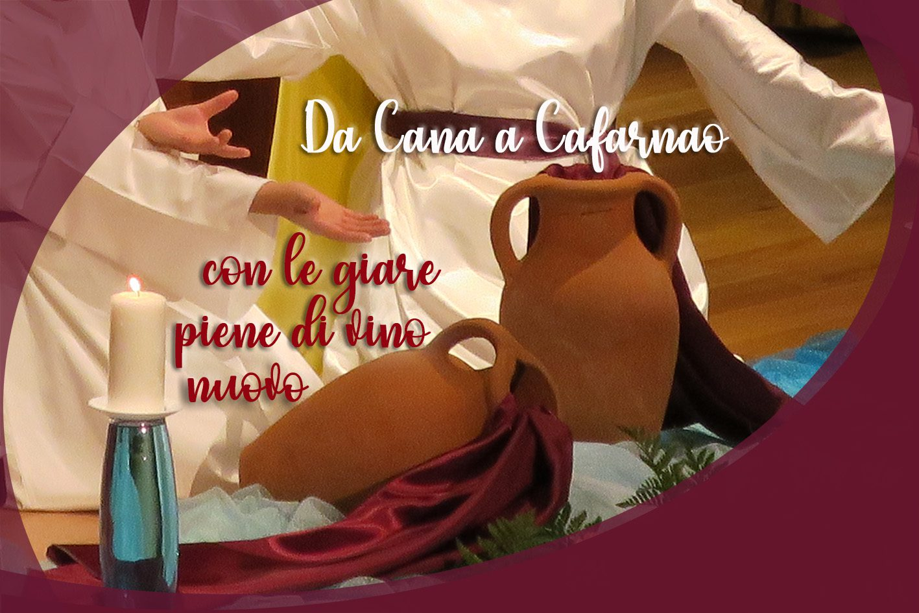

Rome (Italy). Mother and the General Council of the Institute of the Daughters of Mary Help of Christians send a choral message to all the FMA to share the experience of mutual knowledge and communion lived during the XXIV General Chapter. The Council came together for a first meeting in view of the 2022-2027 six-year programming, which will be elaborated in the plenum starting from 24 January 2022.
Mother and the Councilors express gratitude, joy, and hope regarding the experience of GCXXIV, lived in Rome from 17 September to 24 October 2021, ‘a real miracle’ of participation in presence, supported by faith and closeness by the Educating Communities from all over the world that united the Chapter members more closely in heartfelt prayer and opened “new paths for a more shared and choral reflection”.
The presence of Mary, as in Cana of Galilee, was made tangible in the Chapter Hall where Don Bosco’s words resounded, “Mary is here and walks in this house,” permitting each meeting and each decision to be lived in an attitude of listening to the appeals of Jesus and of contemporaneity, and to assume the mandate “I entrust them to you” with the heart of Maìn, to generate life in the educational mission among young people.
The desire to seek together the will of God, journeying as Church, acquired even more importance with the concomitance of GC XXIV and the start of the first phase of the XVI Assembly of the Synod of Bishops, For a synodal Church: communion, participation, and mission. The Chapter work was an experience of synodality, “a laboratory of communion marked by the richness of the interculturality of the Institute: 172 Chapter members, coming from the five continents, citizens of 97 Countries where the Institute is currently present”.
The Chapter Assembly allowed itself to be challenged by the “cry of the young, the poor, and the earth”, deciding to involve the FMA Institute in a more systematic path of conversion to integral ecology, adhering to Pope Francis’ invitation to participate with concrete initiatives by registering on the Laudato si’ initiative Platform. The Circular announces that, “in the person of Mother, the Institute has already registered with the Dicastery for Integral Human Development Service”, paving the way for the adhesion of Provinces, Communities, educational works, groups, and associations.
The Chapter Members, in the name of the entire FMA Institute, expressed their gratitude to Mother Yvonne Reungoat for the fruitfulness of the years of animation and government “with the heart of a mother and unconditional dedication, for her broad, profound, and encouraging gaze towards a prophetic mission among young people”, and to Sr. María Nieves Reboso, Sr. Alaíde Deretti, Sr. María Luisa Miranda, Sr. Maria Helena Moreira, Sr. Vilma Tallone, Sr. Silvia Boullosa, Sr. Lucy Rose Ozhukayil, Sr. Marija Peče, and Sr. Piera Cavaglià, who concluded their service on the General Council.
The XXIV General Chapter was blessed by a historic, unique, and unforgettable event: the visit of Pope Francis who with his words, commits each FMA and all the Educating Communities “to the responsibility of living today with daring and passion, the educational charism as a response to emerging challenges and to prepare for a new future”.
The words of Mother Chiara Cazzuola in the Address at the end of the Chapter event awaken the missionary ardor of the origins and the desire to ‘be’ among the poor young people by listening to their cry more closely, in creative fidelity to the Salesian charism, enriched by colors of the diversity of cultures that make up the FMA Institute:
“Now is the time to go down from Cana to Capernaum with Jesus and Mary, to share life and mission together with the young people and the laity, to let God breathe in our existence and courageously face the challenges we will encounter”.

