We give thanks to God for you – Circular 1011
Mother and the General Council of the FMA Institute send a choral message to all the Daughters of Mary Help of Christians.
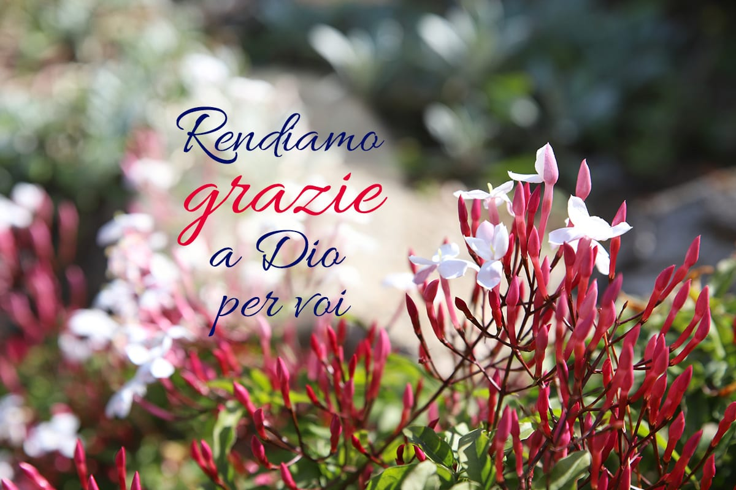
Rome (Italy). Mother and the General Council of the FMA Institute, in the approach of the celebration of the XXIV General Chapter, send a unanimous message of gratitude to all the Daughters of Mary Help of Christians for the fruitful journey undertaken together in the sexennium, making the sentiments of St. Paul their own:
“I give thanks to my God at every remembrance of you, praying always with joy in my every prayer for all of you, because of your partnership for the gospel from the first day until now. I am confident of this, that the one who began a good work in you will continue to complete it until the day of Christ Jesus”. (Phil 1: 3-6)
The “grateful memory of the heart” leads us to express with gratitude and amazement “praise for all that the God of surprises has worked in each one and in the whole Institute in these years of grace”.
The choice for the 2015-2020 sexennium of the encounter that forms and transforms, in the framework of the Gospel passage of the disciples of Emmaus, favored the encounter with Jesus “to walk with young people towards the peripheries of the world”.
Gratitude for the life of the Communities
In the visits made to the Provinces around the world, Mother and the Sisters of the General Council were able to experience the culture of encounter in the Salesian educational mission, which involves young people, educators, collaborators, and families and express gratitude for the spirit of discernment and the sense of co-responsibility with which the most urgent challenges and needs of this time are recognized, in order to respond with creative fidelity.
They express their thanks in a particular way, for ‘being there’ alongside those who suffer, in countries struck by wars and natural disasters, where, despite difficulties and uncertainties, pastoral vitality has not diminished.
“We thank God for the shared journey in listening deeply to contemporaneity, narrating words of life and hope, weaving networks of synodal collaboration, emanating the scent of fraternal relationships with a loving gaze towards all”.
Gratitude to the elderly and sick sisters, who lived the test of the pandemic by remaining “witnesses of the tenderness of the faithful God” (C 106) and continuing to remember the beauty and joy of belonging to Jesus and of being happy Daughters of Mary Help of Christians.
Gratitude for the present and for the future
There are diverse reasons for gratitude for the good learned in the communities of the various parts of the world: for the capacity to accept the guidelines proposed by the Institute, for the commitment in accompanying young people, for the generous solidarity and creative charity, for the missionary spirit lived with audacity, and for the responses to the missionary vocation ad gentes, for the testimonies of holiness, and for the courage to ‘go out’ with which the FMA Institute “continues to generate life and generate to life: love grows through love”.
Thanks for the journey that the Salesian Family makes to grow, consolidate, and be a sign of communion and commitment in the Church and, to each FMA, for cherishing with love the treasure of the charism and of the history of the Institute:
“With your fidelity, with your love for Don Bosco and Mother Mazzarello, you show that the vitality of the Institute today is nourished by its roots. These are what allow us to continue to be generative, to boldly inhabit contemporaneity, and to project ourselves with hope towards a new future”.
We continue the journey with Mary
Accompanied by Mary, who continues to walk with the Educating Communities, and encouraged by Mother Mazzarello “Courage … let us go forward with a big and generous heart (L 47,12)”, we are approaching the third stage of the celebration of 150th anniversary of the foundation of the FMA Institute.
Mother and the Sisters of the General Council entrust to the prayer of all the FMA and the Educating Communities the event of grace of the XXIV General Chapter, which will nourish “a new impetus to travel the path of holiness and creative fidelity to the Salesian charism”.
May the Holy Spirit illumine the ways to be taken to “be with young people, the new wine, in a more fruitful educational freshness”.

