PRESENTATION OF THE THEME FOR STRENNA 2022
“Do all through love, nothing through constraint”
(St Francis de Sales)

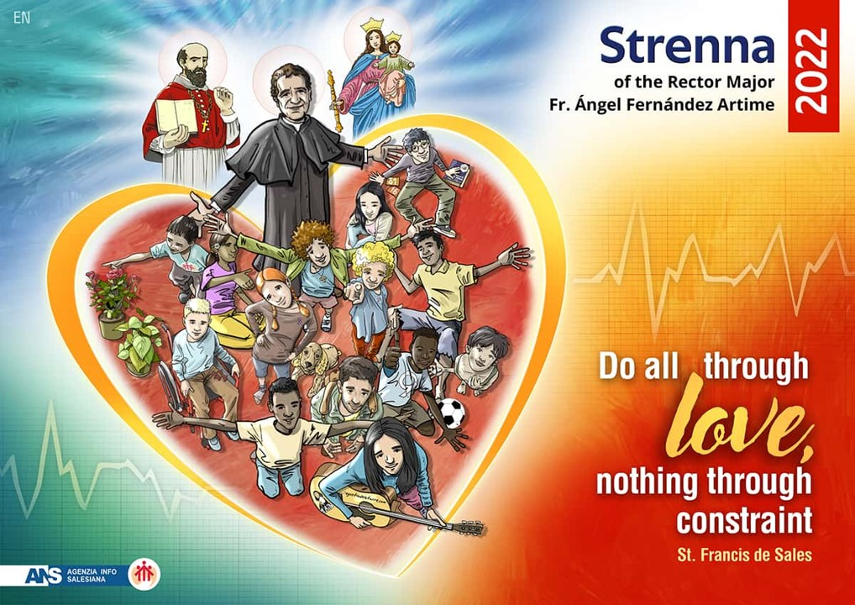
Dear Brothers, Sisters and Friends,
Just six months ago we gave the Daughters of Mary Help of Christians – as has been our tradition since Don Bosco’s time – and the whole Salesian Family, the Strenna for the New Year.
Six months later, therefore, I have been asked to anticipate what could be the guiding theme for the new year 2022, as the different rhythms of the hemispheres where the Salesian presences are located demand. I do so gladly in the hope that it may be of some help.
Quite clearly, in 2022, the year in which we will celebrate the fourth centenary of the anniversary of his death, the theme can only be that of the Spirituality of Saint Francis of Sales,[1] the wellspring of Don Bosco’s Salesian spirit which our father and founder drank from and contemplated at all times, especially when it came to defining his style of education and evangelisation. – to put it in the kind of language we use – of the fledgling Salesian Congregation: “We will call ourselves Salesians”.[2]
We know that Don Bosco was deeply impressed by the extraordinary figure of this Saint. He was an authentic inspiration to him, especially because he was a true pastor, a master of charity, a tireless worker for the salvation of souls…
As a young seminarian, John Bosco took the following resolution before his priestly ordination: “May the charity and gentleness of St Francis de Sales guide me at all times.” And in the Memoirs of the Oratory Don Bosco said: “[The Oratory] began calling itself by the name of St Francis de Sales […] because we had put our own ministry, which called for great calm and meekness, under the protection of this saint in the hope that he might obtain for us from God the grace of being able to imitate him in his extraordinary kindness and in winning souls.”[3]
Of course, this year’s Strenna will also be a wonderful opportunity to recognise and find oneself in the spirituality of St Francis de Sales and to appreciate even more the magnificent characteristics of Don Bosco’s Salesian spirit., as also the precious values of Salesian youth spirituality. We will undoubtedly see ourselves reflected in them and feel called today to be “more Salesian” in our Salesian Family, that is to say, more filled with the spirit of St Francis de Sales, a spirit that permeates our Salesianity as the family of Don Bosco.
Belonging completely to God, living to the full [our] presence in the world
This is probably the most “evolutionary” proposal of St Francis de Sales. Pope Emeritus Benedict XVI expressed it with his usual profundity and beauty when he said that the great invitation that St Francis de Sales addresses to Christians is to “to belong completely to God, living to the full [our] presence in the world and the tasks proper to [our] state”. “My intention is to teach those who are living in towns, in the conjugal state, at court […]” (Preface to the Introduction to the Devout Life). The Document by which Pope Pius IX, more than two centuries later, proclaimed him a Doctor of the Church would insist on this broadening of the call to perfection, to holiness. It says: “[True piety] shone its light everywhere and gained entrance to the thrones of kings, the tents of generals, the courts of judges, custom houses, workshops and even the huts of herdsmen…. […]” (Brief Dives in misericordia, 16 November 1877). Thus came into being the appeal to lay people and the care for the consecration of temporal things and for the sanctification of daily life on which the Second Vatican Council and the spirituality of our time were to insist. The ideal of a reconciled humanity was expressed in the harmony between prayer and action in the world, between the search for perfection and the secular condition, with the help of God’s grace that permeates the human being and, without destroying him, purifies him, raising him to divine heights.”[4]
We certainly find the source of this spirituality in so many of our Lord’s gestures and words in the Gospel and in the simplicity of Don Bosco’s proposal to his boys, in the language and ecclesial context of the 19th century.
So how can we not be attentive so that it may also be a source of inspiration and a pastoral and spiritual proposal for our day?
The centrality of the heart
During his formation in Paris, what triggered Francis’ conversion was an in-depth reading of the Song of Songs under the guidance of a Benedictine priest.
For him it was a light that coloured his whole perception of both God and human life, both his individual journey and his relationships with any other person.
The symbol he chose for the Visitation also shows how the heart is the most telling sign of his human and spiritual heritage: a heart pierced by two arrows: love of God and love of neighbour, a which would also be matched by the two treatises that condense all his thinking and teaching. The first – Treatise on the Love of God – is the fruit of his patient work in the formation of the first group of Visitandines: these are the conferences edited and re-edited in book form. It was also the basis of the formation of Marie Margaret Alacoque who, 51 years after the death of Francis, received the revelations which opened the way to devotion to the Sacred Heart of Jesus in the Church.
Only the index remains of the other treatise, the one on love of neighbour, due to Francis’ premature death on 28 December 1622, at the age of 55.
The humanism of Francis, his desire and ability to enter into dialogue with everyone, the great value he placed on friendship, was so important for personal accompaniment in the way Don Bosco would interpret it… everything is built on the solid foundations of the heart, just as Francis lived it.
Between providence and loving-kindness
Two reflections of his way of feeling God’s heart and opening his heart to his brothers and sisters, intimately related to one another, are his sense of Providence and his way of approaching and interacting with each person, in other words his proverbial gentleness or loving-kindness.
Trust in Providence has roots that come from his formation in Paris and Padua: his “holy indifference”: I trust God’s heart unreservedly, and this disposes me to embrace whatever the sequence of events and circumstances presents me with day by day. I have “nothing to ask and nothing to refuse” with respect to what I know is in God’s hands in every situation. Paul was thinking similarly when he wrote to the Romans: “We know that all things work together for good for those who love God, who are called according to his purpose. For those whom he foreknew he also predestined to be conformed to the image of his Son, in order that he might be the firstborn within a large family” (Rom 8:28-29).
Gentleness of heart when dealing with one’s neighbour, even when that neighbour is unfriendly or anything but pleasant as a character, is a reflection of the same trust before it is a simple trait, this time trust in the human heart, always open to God’s action and always destined for the fullness of life. Gentleness and loving-kindness are missionary approaches, aimed at facilitating as much as possible in every circumstance and situation this encounter between grace and freedom in the hearts of those before me. It is not, then, just a question of good manners.
If we think of the way in which Don Bosco reinterpreted this loving-kindness in his educational system, we understand how profound are the motivations on which it is nourished, just as it was for St Francis de Sales.
Practical training in the mission in the Chablais, and Don Bosco’s Da mihi animas
The tough experience of evangelisation in the Chablais between 1593 (his address as Provost) and 1596 (Christmas Masses at Thonon) is where the mission set the concrete tone for his whole life. It was extremely difficult (“here everyone has insults on their lips and stones in their hands”) but it was a crisis that brought growth and transformed the missionary in the first place, even before it did so for his beneficiaries.
It is also very interesting to read those years as a Eucharistic pedagogy. The visible Eucharist, celebrated with a large crowd, carried in procession… after years of emptiness (Christmas 1596…), became the point of arrival after going through a long desert, where he was the one who lived from the Eucharist and became its presence in a hidden way among the people who were previously hostile and whom he approached and made friends with, one by one.
Bearing in mind that our Salesian presences are for the most part among non-Catholics, this Eucharistic spirituality becomes prophetic: from within the missionary it reaches out with great patience and perseverance to those to whom it is sent, without renouncing explicit proclamation but knowing how to wait for God’s long time, and not waiting for the faithful to fill the church but mixing with the flock wherever and however it may be…
And with the Eucharist, and on the same wavelength, is the centrality of the cross and confidence in Mary.
All this speaks to us of the educative and evangelising passion of Don Bosco who, in the presence of the Lord in the Eucharist and the strong presence of Mary in the life of the Oratory, in the midst of his boys, found the daily strength to realise the Da mihi animas, cetera tolle.
But how do we communicate?
Francis de Sales is the patron saint of journalists. His charism as a communicator is worth grasping, where there is a splendid agreement between love and interest in reflection, culture, humanism in its most beautiful expressions on the one hand, to be promoted, encouraged, harmonised by creating and fostering dialogue between those who are more capable and richer in these fields and, on the other, Francis de Sales as the master of communication for everyone, a great disseminator given the means and circumstances in which he lived. It is enough to think of the enormous number of letters in which a significant part of his apostolate as bishop and saint was condensed.
In this too we have a disciple in Don Bosco who follows his master’s zeal, with the new means at his disposal (the popular “mass” press): 318 published works of Don Bosco in 40 years… on average about one every two months. And at the same time it is a message for us of the utmost relevance and a real challenge in today’s world where communication is at the centre of reality.
Francis de Sales in Don Bosco’s way of accompanying young people: charisms flourish and bear fruit in each other
There is a true “communion of saints” within the educational and spiritual art of Don Bosco, which did not come from nothing, but was nourished by deep roots, the work of the Spirit in the history of the Church that preceded him. It is neither an addition nor a repetition: it is rather a new flourishing and bearing of fruit that feeds on the work of the Spirit that vivified the Church with Francis of Assisi and Ignatius, with Dominic and Teresa of Avila.
A fine proposal for the Church today, and certainly for the Salesian Family of Don Bosco, is rightly that of growing in the art of accompanying the journey of faith, especially of so many boys, girls and young men of the world who do not know God, and who at the same time hunger and thirst for him often without knowing it. It is very “Salesian” to feel and truly believe that each person needs “a friend of the soul”[5] in whom to find advice, help, guidance and friendship.
I would like to conclude these succinct outlines, around which the Strenna for 2022 for the whole Salesian Family of Don Bosco around the world will be able to develop, with the invitation that Pope Benedict XVI addresses to us at the end of his General Audience, asking us, in a “spirit of freedom”, to follow the exemplary witness of St Francis de Sales, a true example of the Christian humanism that makes us feel that only in God do we find the satisfaction of the desire and nostalgia we feel for Him: “Dear brothers and sisters, in an age such as ours that seeks freedom, even with violence and unrest, the timeliness of this great teacher of spirituality and peace who gave his followers the “spirit of freedom”, the true spirit, St Francis de Sales is an exemplary witness of Christian humanism; with his familiar style, with words which at times have a poetic touch, he reminds us that human beings have planted in their innermost depths the longing for God and that in him alone can they find true joy and the most complete fulfilment.”[6]
Fr Ángel Fernández Artime, SDB
Rector Major
Rome, 22 July 2021
[1] Cf. St Francis de Sales to Jane Frances de Chantal: “This is the rule of our obedience which I write for you in capital letters: DO ALL THROUGH LOVE, NOTHING THROUGH CONSTRAINT – LOVE OBEDIENCE MORE THAN YOU FEAR DISOBEDIENCE. I leave you the spirit of freedom, not that which excludes obedience, which is the freedom of the world, but that liberty that excludes violence, anxiety and scruples (Letter 234 to Jane Francis de Chantal. 14 October 1604, in Oeuvre de saint François de Sales, XII, 359 cit. in E. Alburquerque Frutos, Una spiritualità dell’amore: San Francesco di Sales, Torino, Elledici 2008, 46).
[2] Cf. P. Chávez Villanueva, Salesiani da centocinquant’anni, Roma, LEV 2019, 40.
[3] G. Bosco, Memoirs of the Oraotry of St Francis de Sales from 1815 al 1855, in ISS, Salesian Sources 1. Don Bosco and his work, Roma, LAS 2014, 1244.
[4] Benedict XVI, General Audience, Rome 2 March 2011.
[5] G. Bosco, op. cit., 1184.
[6] Ibidem.

